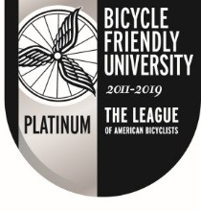
Agenda
Campus Bicycle Advisory Committee
Colorado State University
Thursday, February 13, 2020
11:30 – 1:00 pm
Lory Student Center, Room 226-28
- Call to order (Elizabeth)
- Introductions/Roundtable – 20 min
  - Name/Affiliation/News to share?
- Draft design solutions for several conflict intersections on campus – 20 min David Hansen
- Set a firm date for the project tour – Aaron Buckley
- Continue to write /approve bike letter to President McConnell – 15 min: (wait for next meeting)
- Set agenda for next meeting/Adjourn – 5 min

-----------------------------------------------------------------------------------------------------------------------------------------
PD stats for January:
- CSU Bike Tickets Issued: 3
- Bike Warnings Issued: 9
- CSU Traffic Tickets Issued: 80
- Traffic Warnings Issued: 298
- PD Sold Bicycle Registrations: 78
- PD Provided Bicycle Lock-Cut Services: 8
Looks like theft for both parts and bikes are down for the year based on the small amount of information we have so far.

